Clemson Metube

**Introduction:**

Metube Project is to build a database-driven media-file sharing website similar to Youtube. But unlike YouTube system in which video is the only media type hosted, the content of MeTube system includes graphics objects, video, audio, images, and animation clips.

The MeTube project we develop is on: <http://webapp.cs.clemson.edu/~htaj/ClemsonMetube/index.php>

**System Design:**

MeTube is a modified version of YouTube system. The major objective of MeTube system is to let the users to upload and download graphics objects, video, audio, images, and animation clips.

Using MeTube system, users are able to upload and download multimedia files through a web interface. Users can also view multimedia files online through proper media players embedded in the web browser. A user must register an account to upload multimedia files and manage their uploaded files. When a user uploads a multimedia file, Meta information about the multimedia file should also be entered through the Web interface. The Meta information includes the title, description, and keywords used for searching the multimedia file. The user can also specify how to share the media file with others (for instance, share with everybody or just friends, allow discussion or not, allow rating or not, etc.).

A Web interface must be designed to allow the registered users to annotate, update, and remove their uploaded multimedia files. Registered users can display all multimedia files they uploaded, downloaded, and viewed with an appropriate Web interface when they log into their accounts. They can also organize media files they have viewed into playlists. A registered user also owns a channel which contains all multimedia files uploaded by this user. A registered user can subscribe to another user’s channel if that user has allowed other users to view their uploaded multimedia files. A registered user can also create a favorite list of multimedia files. A registered user can maintain a contact list. A registered user can only send messages to users in his contact list.

A user can organize their contacts into different categories such as adding them into their contact list and later can add them into their friend list. And also he/she can also put a list of users into a blocked list so that these users cannot communicate with him/her. A user can also block other users from viewing/downloading the media files he/she uploaded. A user can invite users in his/her contact list to view/download media files through a simple messaging system. This messaging system works as a web-based email system with which users can send, receive, reply, and delete messages. A user can also create or join a discussion group in which users share interests and multimedia files, and discuss them. Once a user creates or joins a group, it can start a discussion topic and post comments on the discussion topic or multimedia files.

A search interface must be implemented in MeTube system. A user can use this interface to search multimedia files based on keywords or media file properties (such as dates uploaded, file size, data format, etc.). Users can also browse multimedia files by category, time, popularity, etc. After a user finishes viewing a multimedia file, he/she can rate the file based on his/her viewing experience and make comments on this file if the owner who uploaded the multimedia file enabled the discussion option for the file. When a user selects a multimedia file to view, links to other related media files should be provided (This is called recommendation).

The MeTube system also provides with the guest user as an option if the user using the system does not want to create a profile and just want to look into the system and see the various modules and public media files. The guest user however will not have access to any of the other users nor can create a contact list or add any users to their friend list.

**Entity Relationship Diagram and Database Schema:**

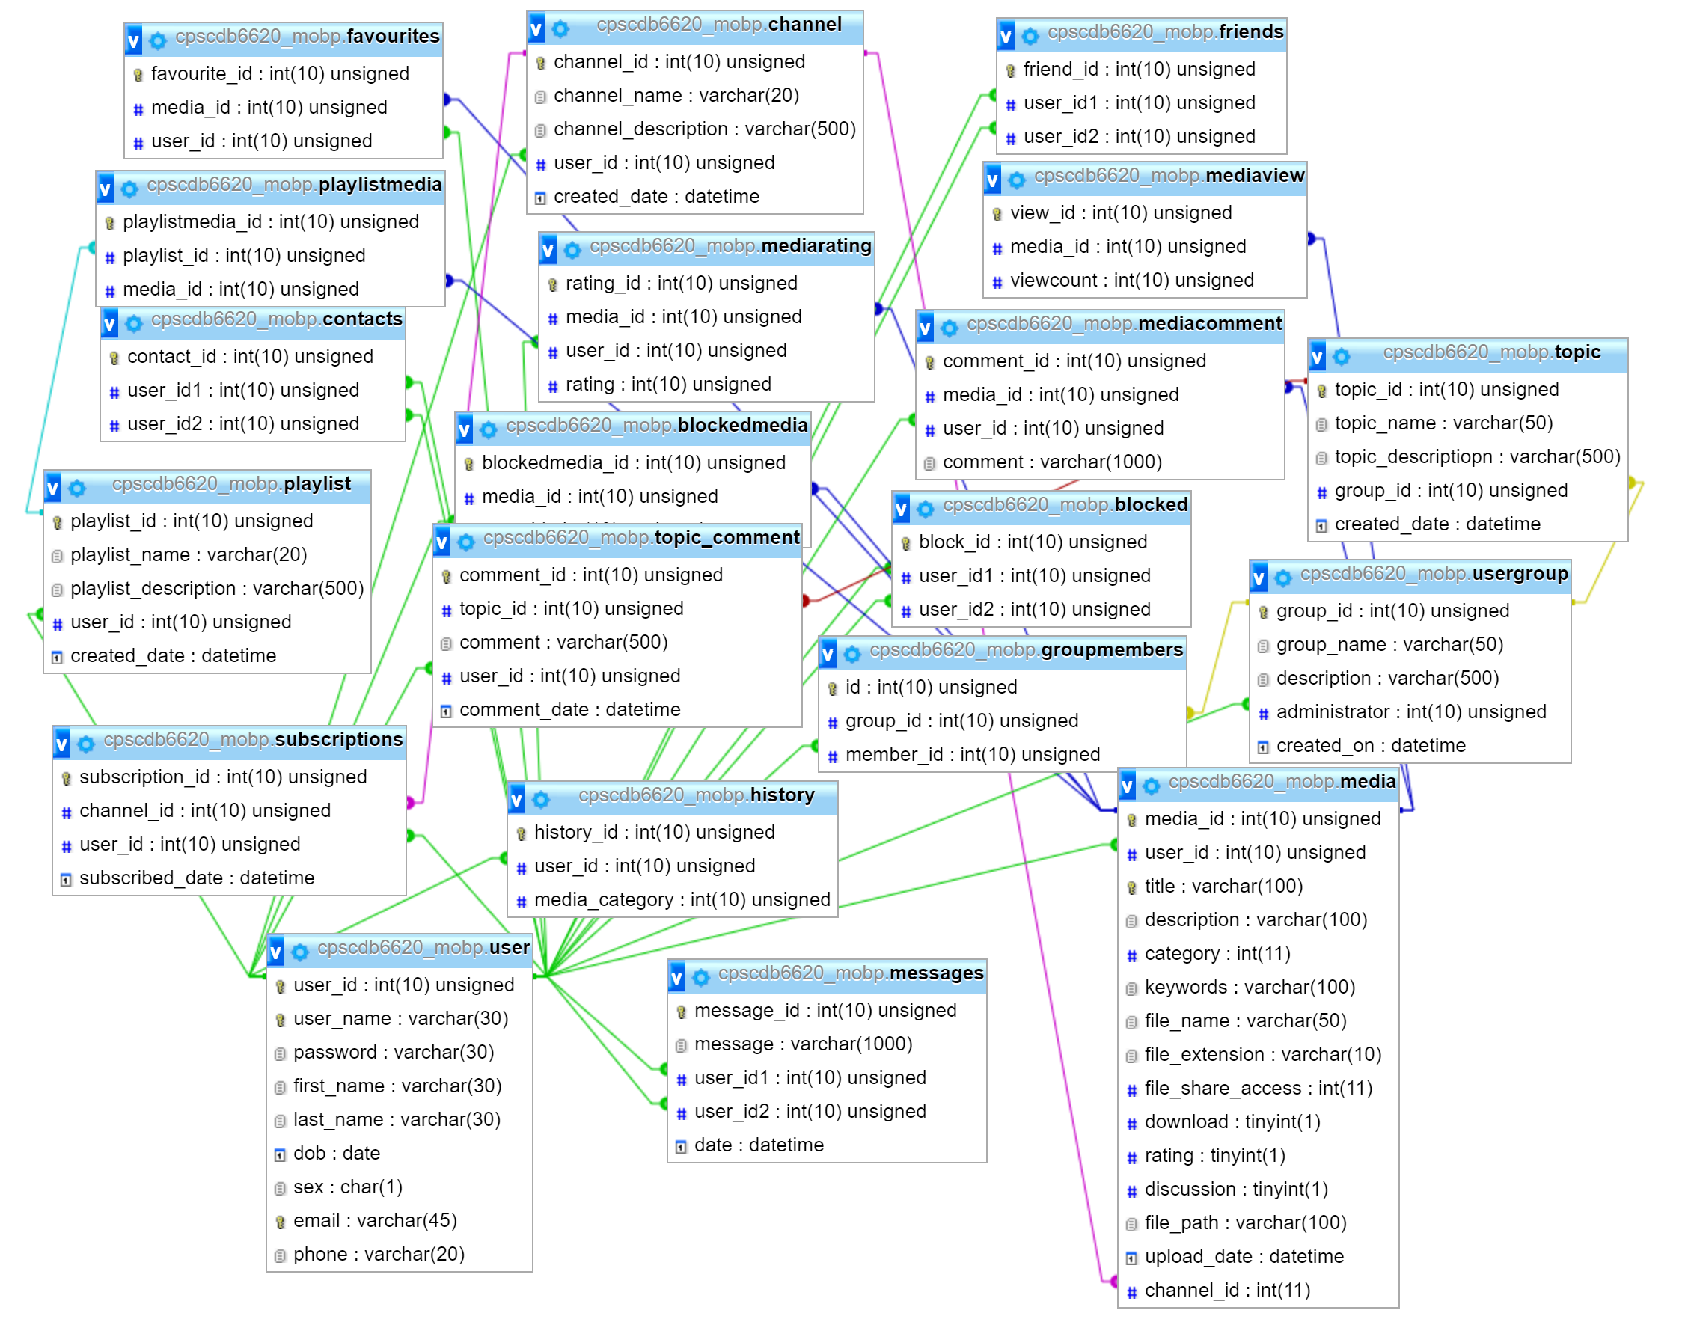

**Function Design:**

Clemson Metube project is designed based on the basic source code design provided in the course.

Clemson Metube is the parent folder which contains all the .php,.css, .js, media files.

All the php files are present inside the ClemsonMetube folder, except that the header.php,footer.php,sidebar.php are located in parts folder. The files in the parts folder are reused across other php files.

Index.php contains the defines the home/welcome page for Clemson metube application. Register.php defines the form, which is presented to the user to create a new account.

Function.php file contains all the important functions such as user validation, getusername,remove block, createchannel etc.

Css folder contains all the styling files used for our project.Media contents that are uploaded through the metube website are stored in different folders based on the category. For instance, we store the audio files under audio folder, Racing Sports files under videos/sports folder. Fonts folder contains various fonts used for the project.

**Implementation Details:**

**Registration**

POST information (username, email, password and profile info) -> check (username used or not, email format and email used or not, password match, profile info filled in or not) -> all good insert to User table; otherwise show error message.

**Sign in**

POST information (username and password) -> check (username and password tuple match or not with the User Table) -> all good, sign in, otherwise show error message

**Contact list**

Check (whether in the block list or the friend list of the user that you want to add) -> No, insert to Contact table; Yes, cannot add to the contact list.

**Friend list**

Check (whether in the block list of the user that you want to add) -> No, insert to Friend table; Yes, cannot add to the friend list

**Block list**

POST information (the user you want to block) -> insert to Block table

**Media recommendation**

Select medias from Media and MediaKeyword table that have similar type, keyword and category with current media -> show to user

**Upload and metadata input**

POST information (file, metadata, access type (everybody, friends or just you), download type (everybody, friends, or just you), allow discussion or not, allow rating or not) -> check (file selected or not; metadata information input or not) -> Yes, insert to Media table; No, error message

**Download/view and Media sharing/blocking**

Check (access type and download type) and determine whether you are allowed to download/view -> Yes, show “download” and “media” will be visible; No, doesn’t show download and media file will not be visible.

**Browse by category**

POST information (category you want to view) -> select the category from Media table and show to the user

**Channel**

POST information (the user you want to subscribe) -> insert to Subscription table

**Word Cloud**

Scan the MediaKeywords table and count all the keywords based on their occurrences -> generate word cloud figure using Jquery and SVG in HTML (the more occurrence, the larger size; the less occurrence, the smaller size)

**Messaging**

POST information (user you want to send and contents) -> insert to Message table and show to both sender and receiver

**Commenting**

POST information (media you want to comment and comment you want to add) -> insert to MediaComment table and show under the media

**Media rating**

POST information (media you want to add rating) -> insert to MediaRatings table and show under the media

**Create Group Discussion**

Create a group, POST information (group name) -> insert to Group table

**Join Group Discussion**

Join a group, POST information (the group you want to join and user id) -> insert to GroupUsers table

**Start a group discussion**

Start a discussion, POST information (group id, discussion title, contents) -> insert to Topic table

**Post comment in a discussion**

Post comment, POST information (Topic id, group id, user id, contents) -> insert to TopicComment table

**Keyword based search**

POST information (keyword you want to search) -> select conditionally from table Media -> if there exist results, show; otherwise, show no result

**Feature based search**

POST information (feature you want to search) -> select conditionally from table Media -> if there exist results, show; otherwise, show no result

**Favorite media**

POST information (the media you want to favorite) -> insert to FavoriteMedia table

**Most viewed media**

POST information (number of views) -> select the number of views attribute from Media table and show to user

**Most recently updated media**

POST information (time of update) -> select the time of update attribute and order the selection from Media table and show to user

**Create Playlist**

Create new playlist, POST information (title)-> insert to Playlist table

**Add Playlist**

Check (any playlist exists for the user) -> Yes, show the “add playlist” button; No, not showed -> POST information (the playlist you want to add) -> Insert to PlaylistMedia table

**Remove Playlist**

Remove media from the playlist -> delete from PlaylistMedia table

**Profile update**

POST information (the information you want to update) -> check (whether it is the user’s profile) -> update to User table

**Test Cases and Testing Results:**

**Case 1:**

A user can register and create an account in the MeTube system. All the values entered by the user needs to be validated. Password needs to be checked and email format needs to be checked during the registration. A user can sign in to the profile and check if the registration was successful.

**Steps:**

1. Click on “Sign Up” in the home page.

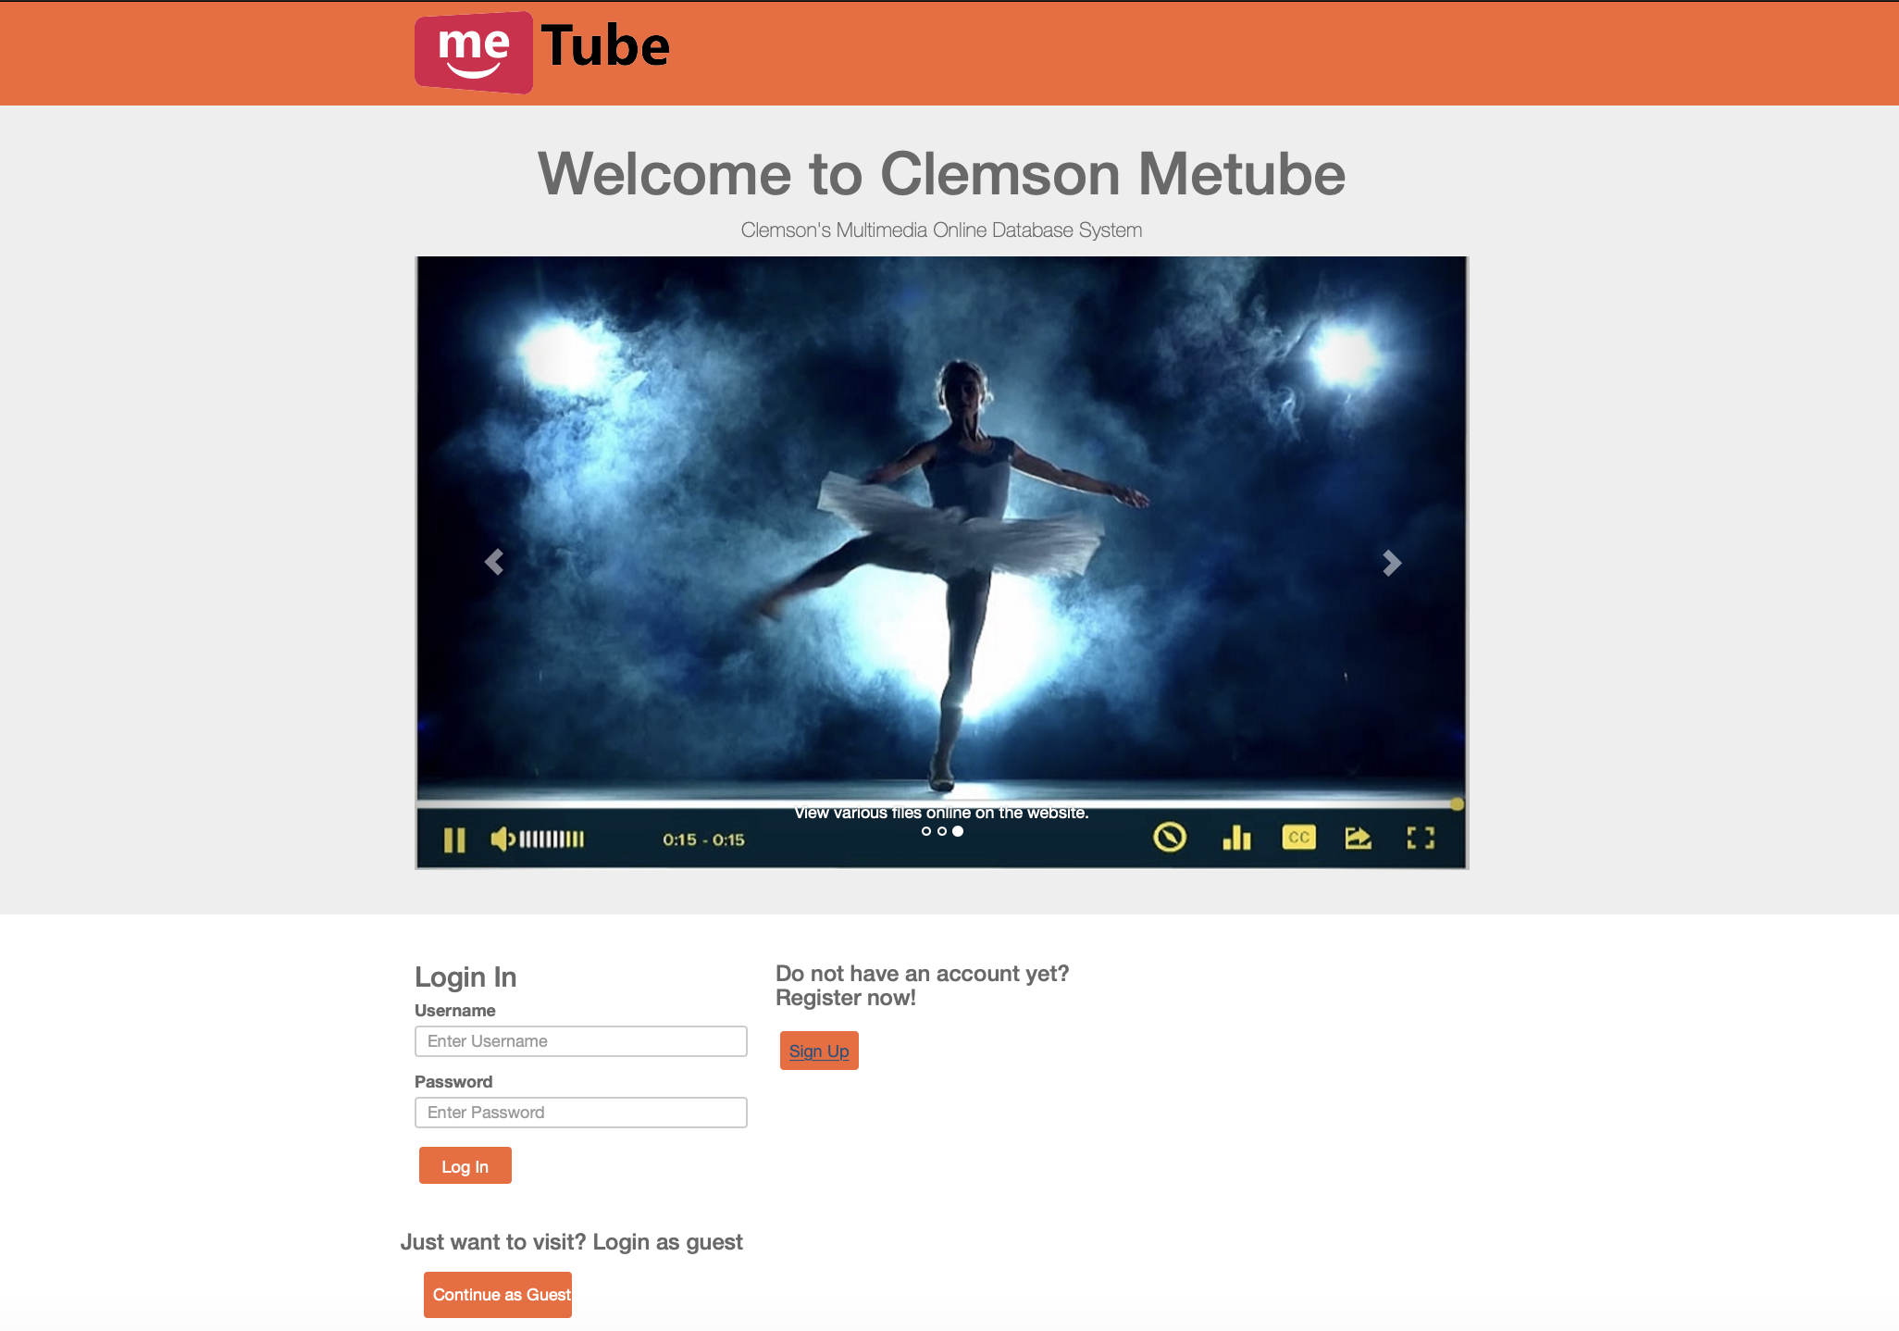

1. Fill out all the fields in the registration page and check for the various validations if email is typed in the format and DOBis entered in the proper format and submit the form by clicking on register.

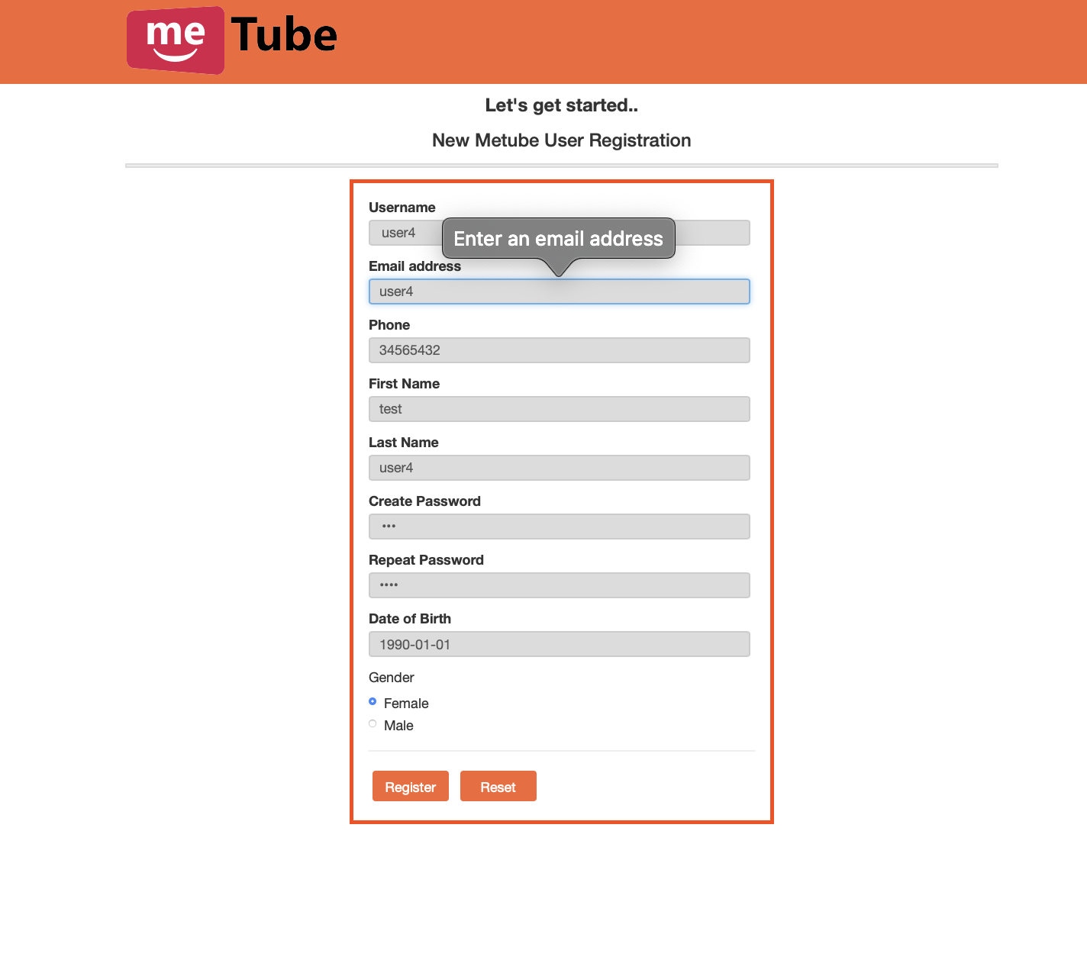

1. Confirm that the page will redirect into the MeTube system and the user will be logged in. User can view the menu options and find “logout” button on top right.
2. Log out of MeTube and try signing back in using a wrong password or wrong username or email. Confirm if the user has not been signed in into the system.

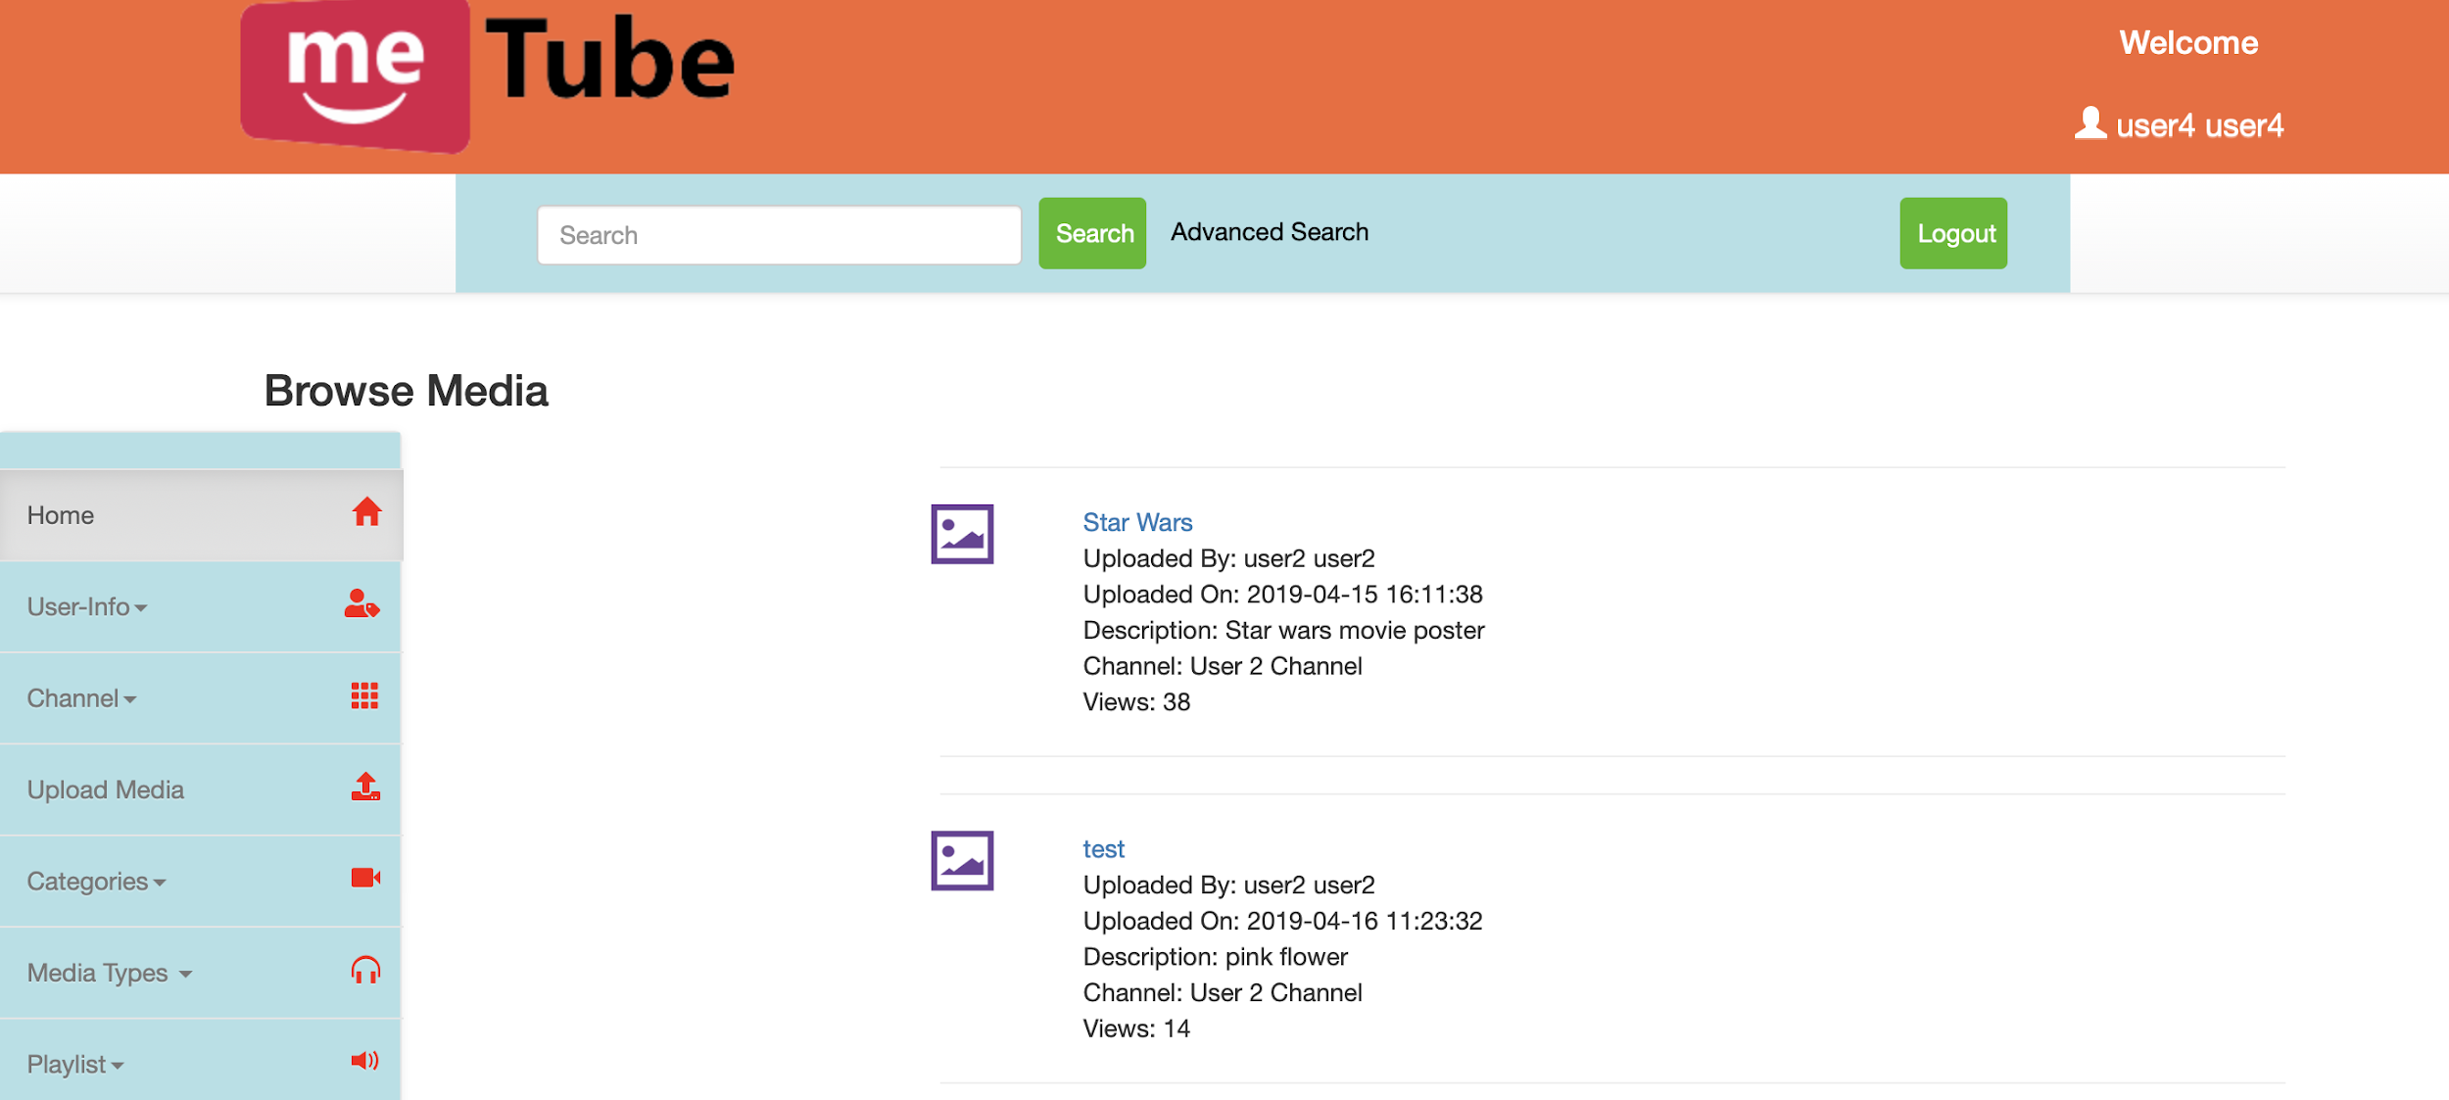

**Testing Result: Pass**

**Case2:**

A user can sign-in and update the profile such as changing the name or password or other personal information. A user can also delete the account.

**Steps:**

1. Sign-in to your account using your username and password.
2. Click on the user name along with the icon present on top right in the header section.
3. Confirm that the page redirects you to the profile information. There will be an option to edit the profile.
4. Change the information required and click on “Save”.
5. Click on the user name along with the icon and confirm if the profile has been updated.
6. To delete the account click on “Delete Account” in the same edit profile.
7. Confirm if the account is deleted by trying to login again.

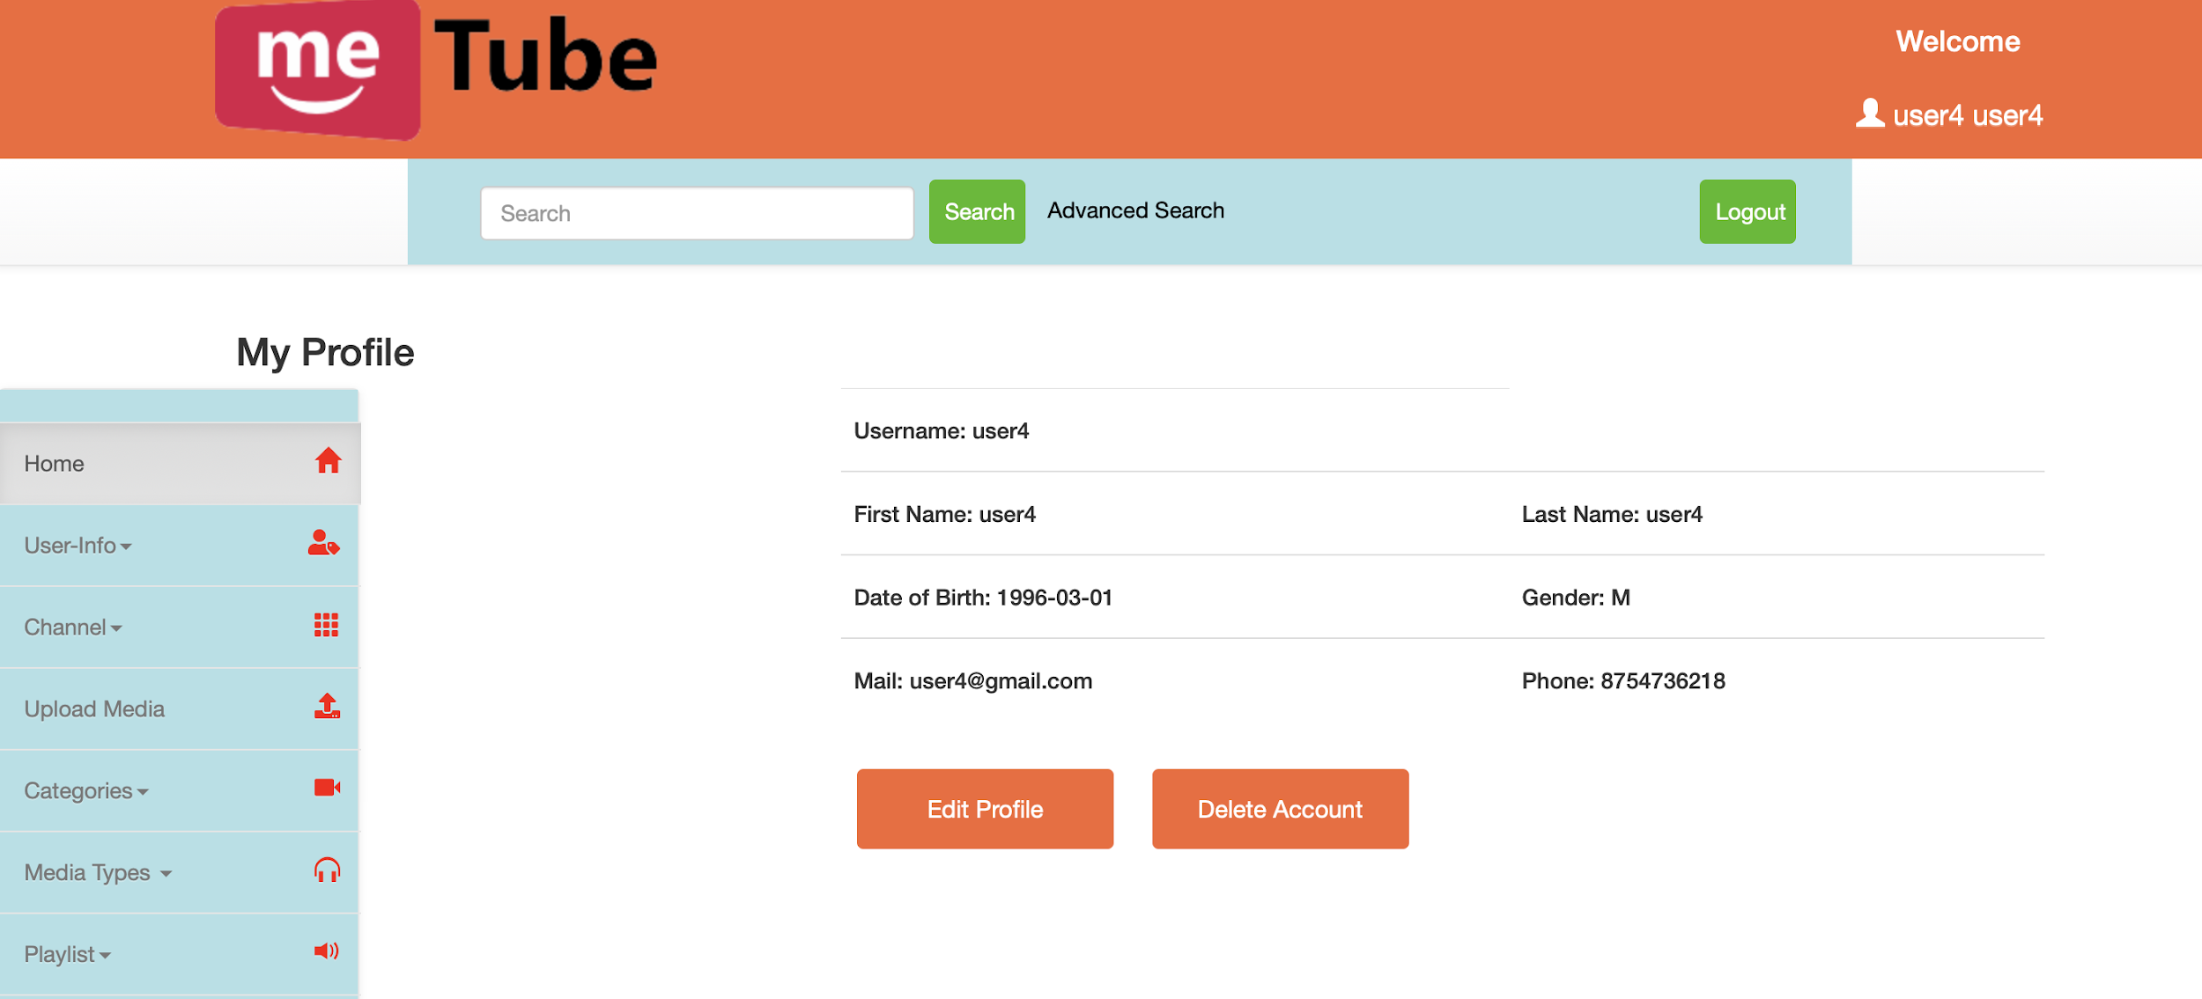

**Testing Result: Pass**

**Case3:**

A user has a user list, contact list, friend list and block/foe list. User can add users from user list to contact list and from user list he can assign other users to be in the friends or can block the user.

**Steps:**

1. Click on “User-Info” in the sidebar menu on the left.
2. Click on “Users” and click on random users and add them in your contact list.
3. Again under “User-Info” go to “Contacts” and either add them as friend or block the user or can remove from the contact list.
4. Confirm if the users are being added to the friend list or are blocked or removed from the contact list by checking Friends, Blocked/Foe or Users respectively under “User-Info”.

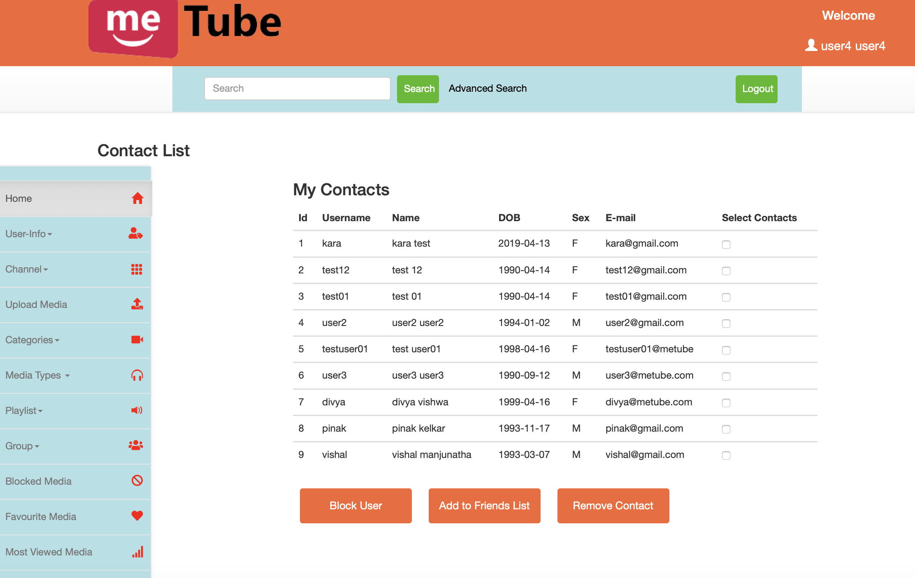

**Testing Result: Pass**

**Case4:**

A signed-in user should be able to upload multimedia files into the Metube system only after creating a channel. Once a channel is created the user will be able to upload mediafiles. During uploading, the user should be able to input the meta-information about the multimedia file, including the title and description of the media file, and keywords used for searching the media file. Accessing the media files: a user can specify how to access the media file with others (for instance, share with everybody or just friends, allow discussion or not, allow rating or not, etc.) A user can delete any the channel created and all the associated media files uploaded will be deleted.

**Steps:**

1. Use MeTube as a Visitor (Not signed in)
2. Confirm that the “Upload Media” button gives a message about guest user privileges. Sign in as a user and Click on “Upload Media” in the left sidebar and confirm that it provides you with an error message about no channel created.

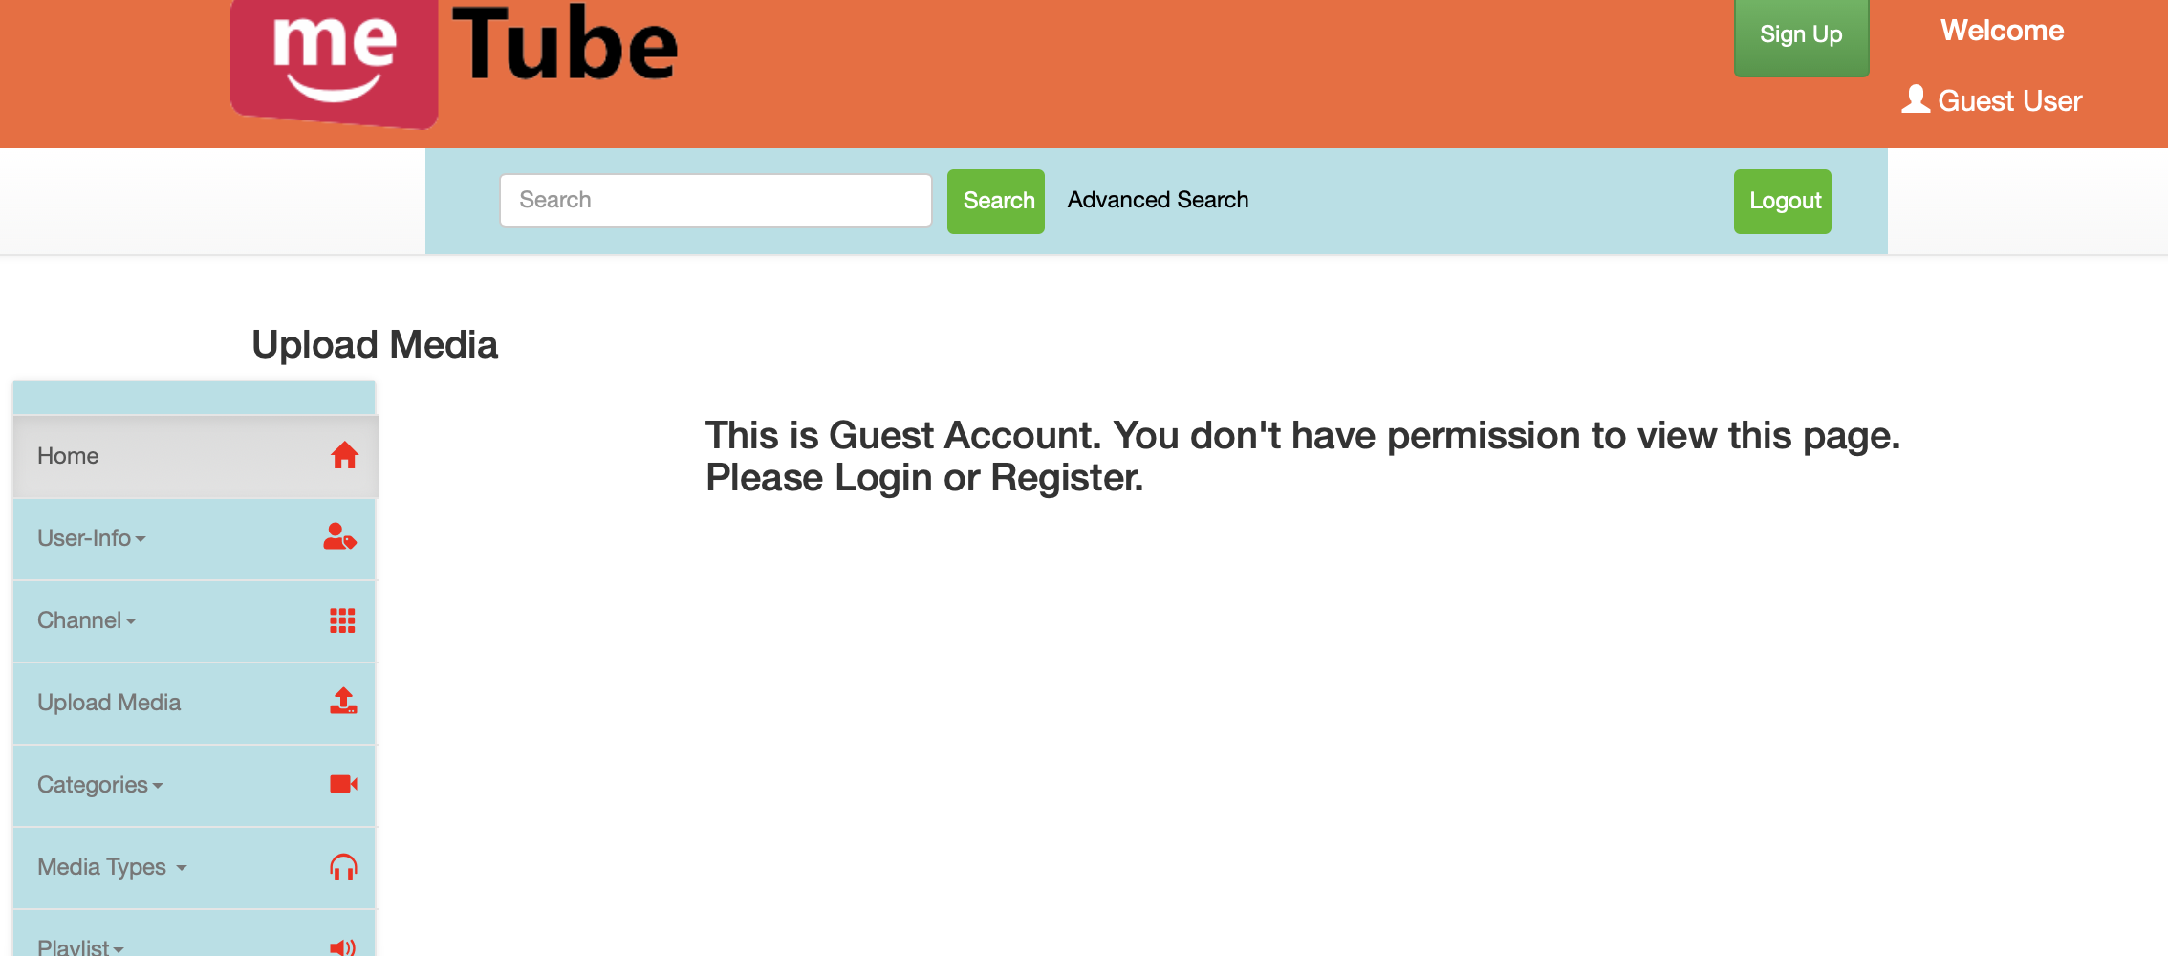

1. Create a channel by going under “Channel” in left sidebar and clicking on the “Create channel” option and add a channel name and description.

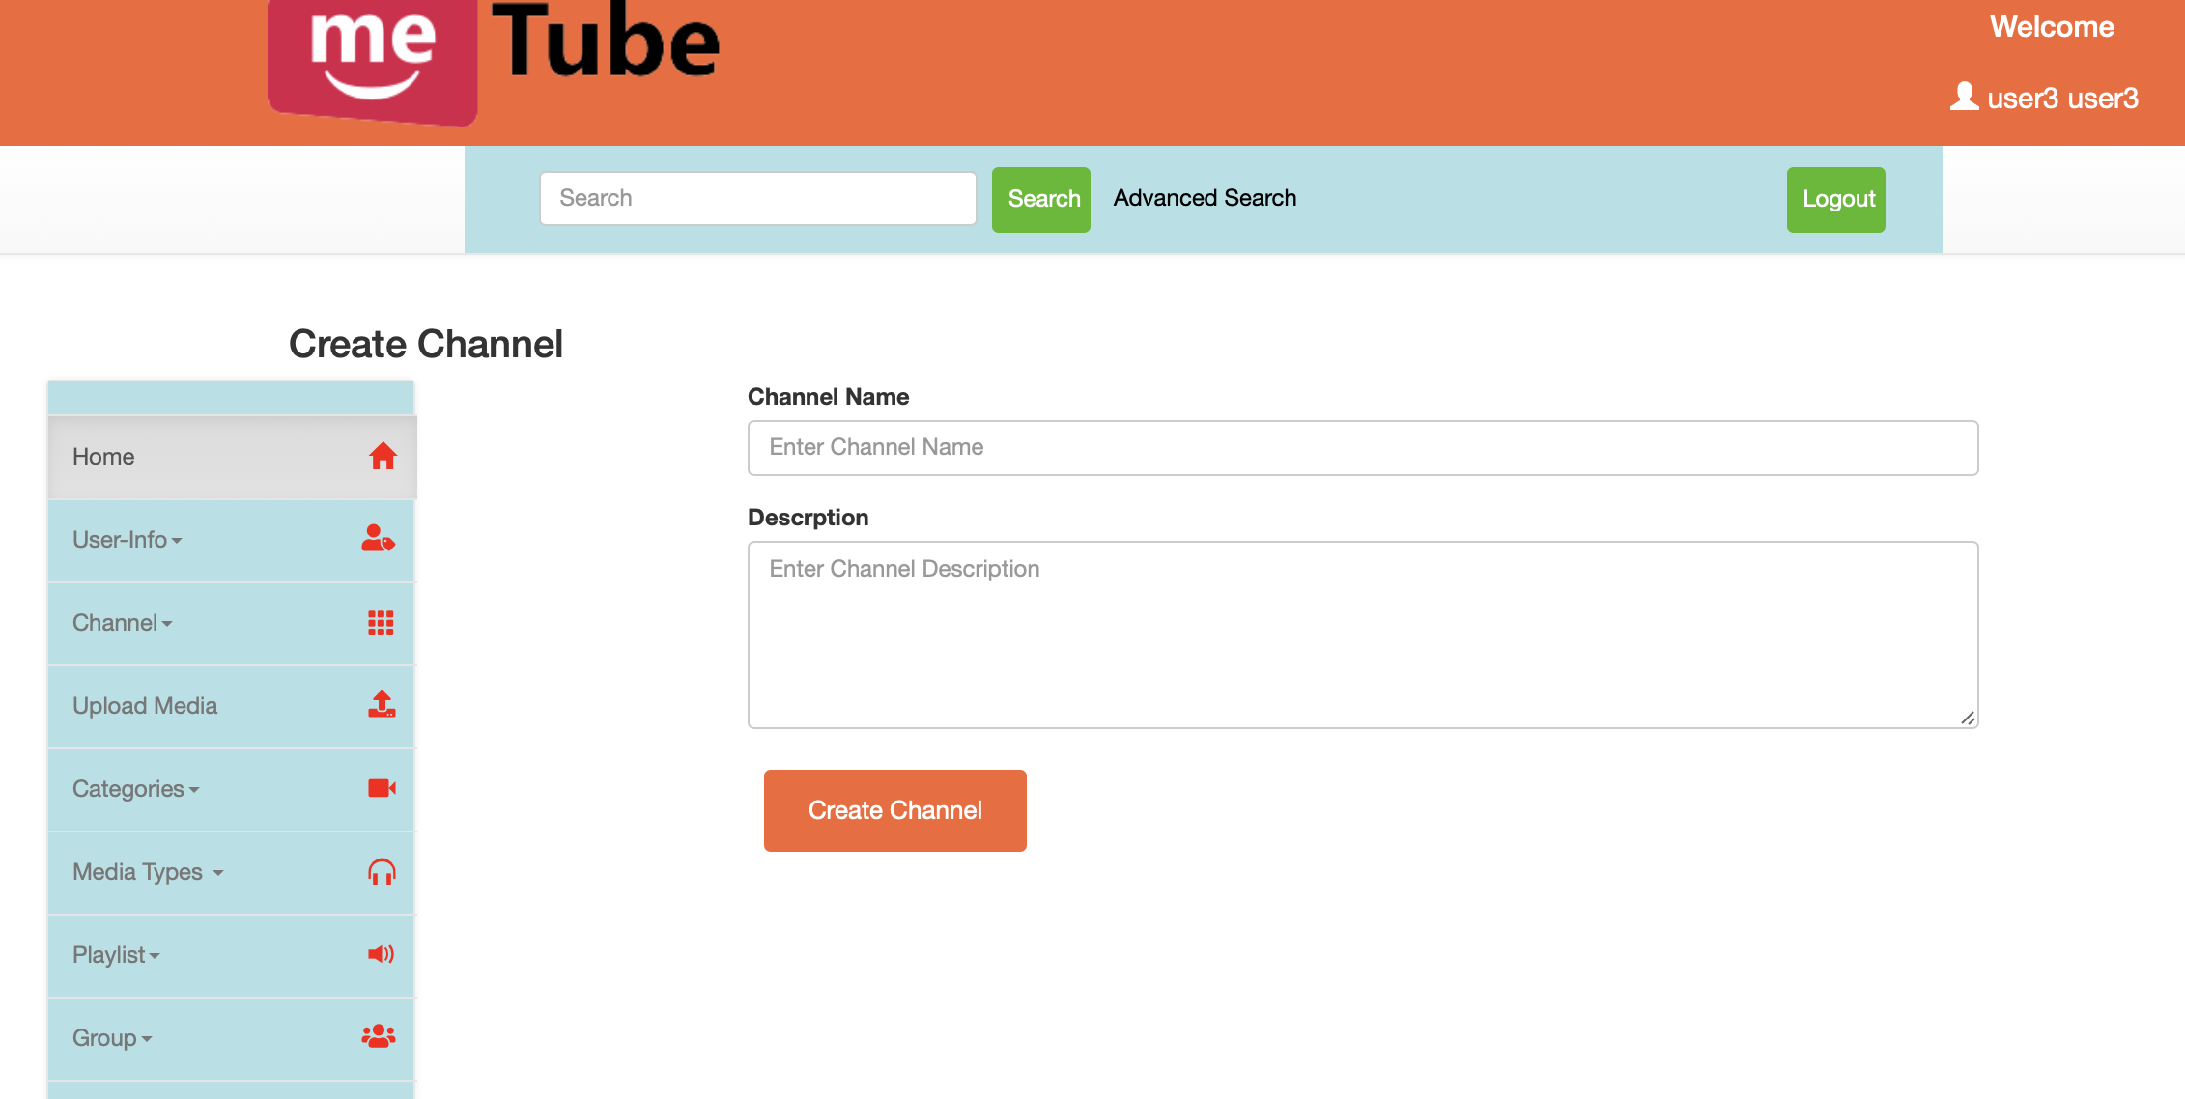

1. Confirm if the channel is created by going under “My channel” option under “Channel”.
2. Then click on the “Upload Media” button present in the sidebar on the left.
3. Fill out the form to upload a file and select allow discussion or not, allow rating or not and which channel and access options.
4. To confirm with media upload you can check it in the channel you have uploaded with and based on access privileges you can sign in using other user and search for the uploaded media file.

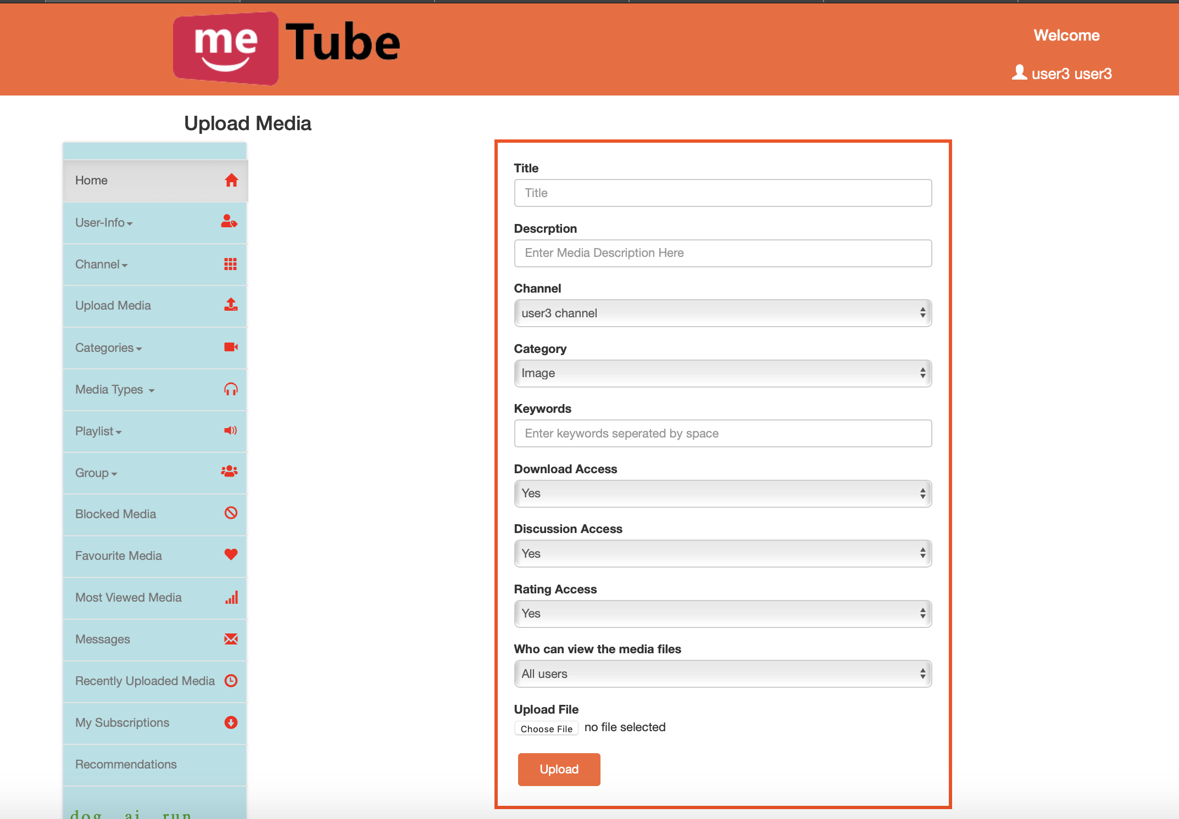

1. Continue back and sign in with the previous user and go to “My Channel” option under “Channel” in the sidebar. Select the channel and click on remove channel.
2. Confirm that the channel and associated media is deleted.

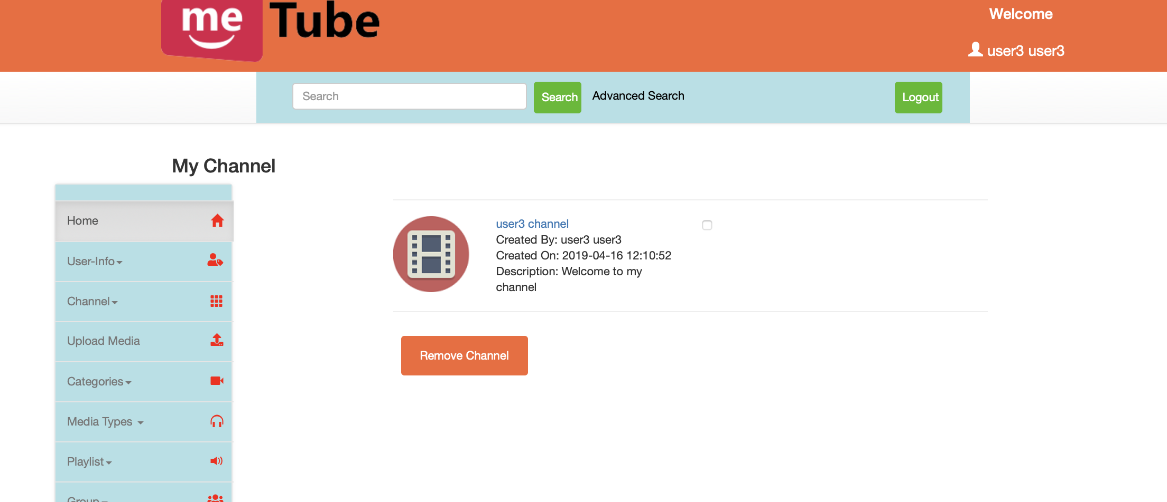

**Testing Result: Pass**

**Case5:**

MeTube visitor user will be able to view media files uploaded and made available in the MeTube system through the required media player that is embedded in the web interface.

Blocked User: A user can block other users from downloading the media files that the user has uploaded. The user has the privileges to block and unblock any user as per his/her needs.

**Steps:**

1. Ensure that you continue as guest into the Metube system to represent a visitor user.
2. Find a media that is shared in public by the other users and confirm that as a visitor user you are able to view the media files using the embedded media player in the web interface.
3. Sign in as User A and add a media and block User B

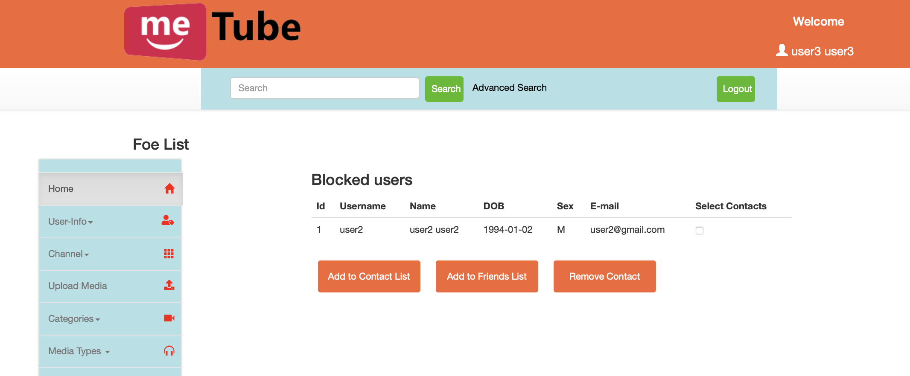

1. To confirm that the blocked user cannot download the media files now sign in as User B and confirm if User B is able to download the media file uploaded by User A.

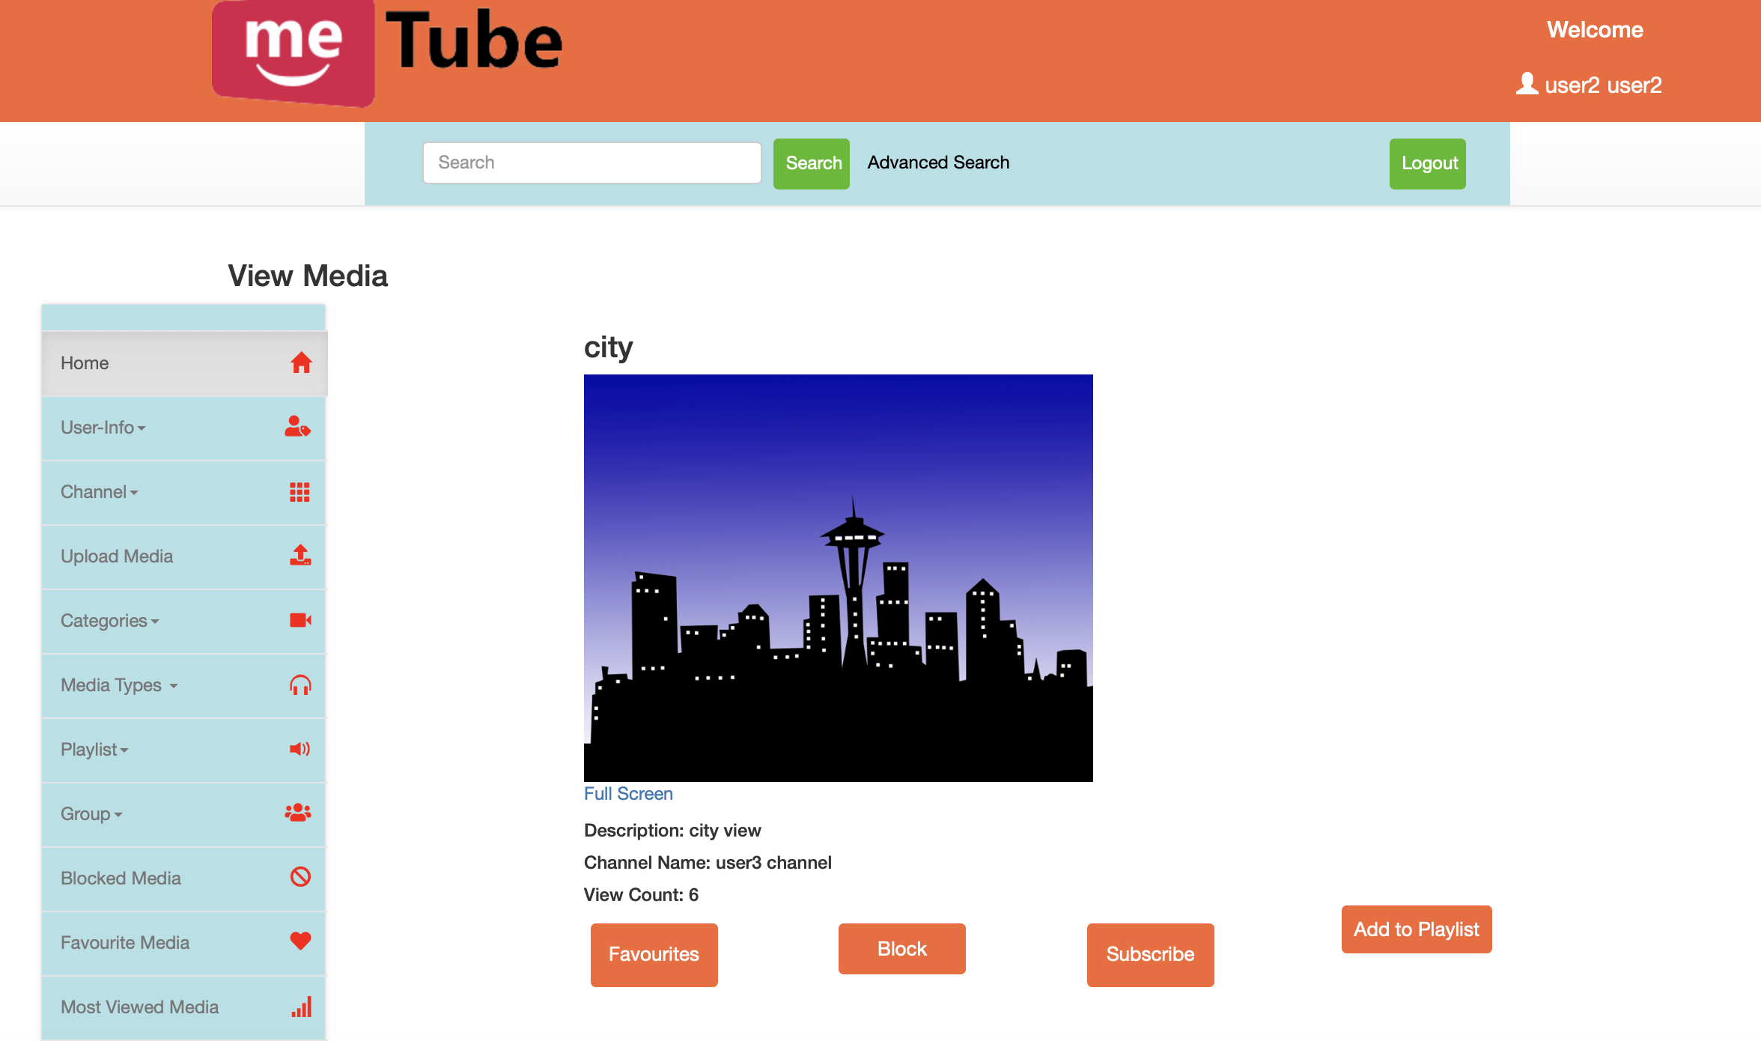

**Testing Result: Pass**

**Case 6:**

All the users should be able to browse the media files based on categories.

**Steps:**

1. In order to view the various videos click on “Categories” in the sidebar on the left.
2. To view the audio and image media files click on “Media Types” in the sidebar on the left.
3. Select the one you want to view.

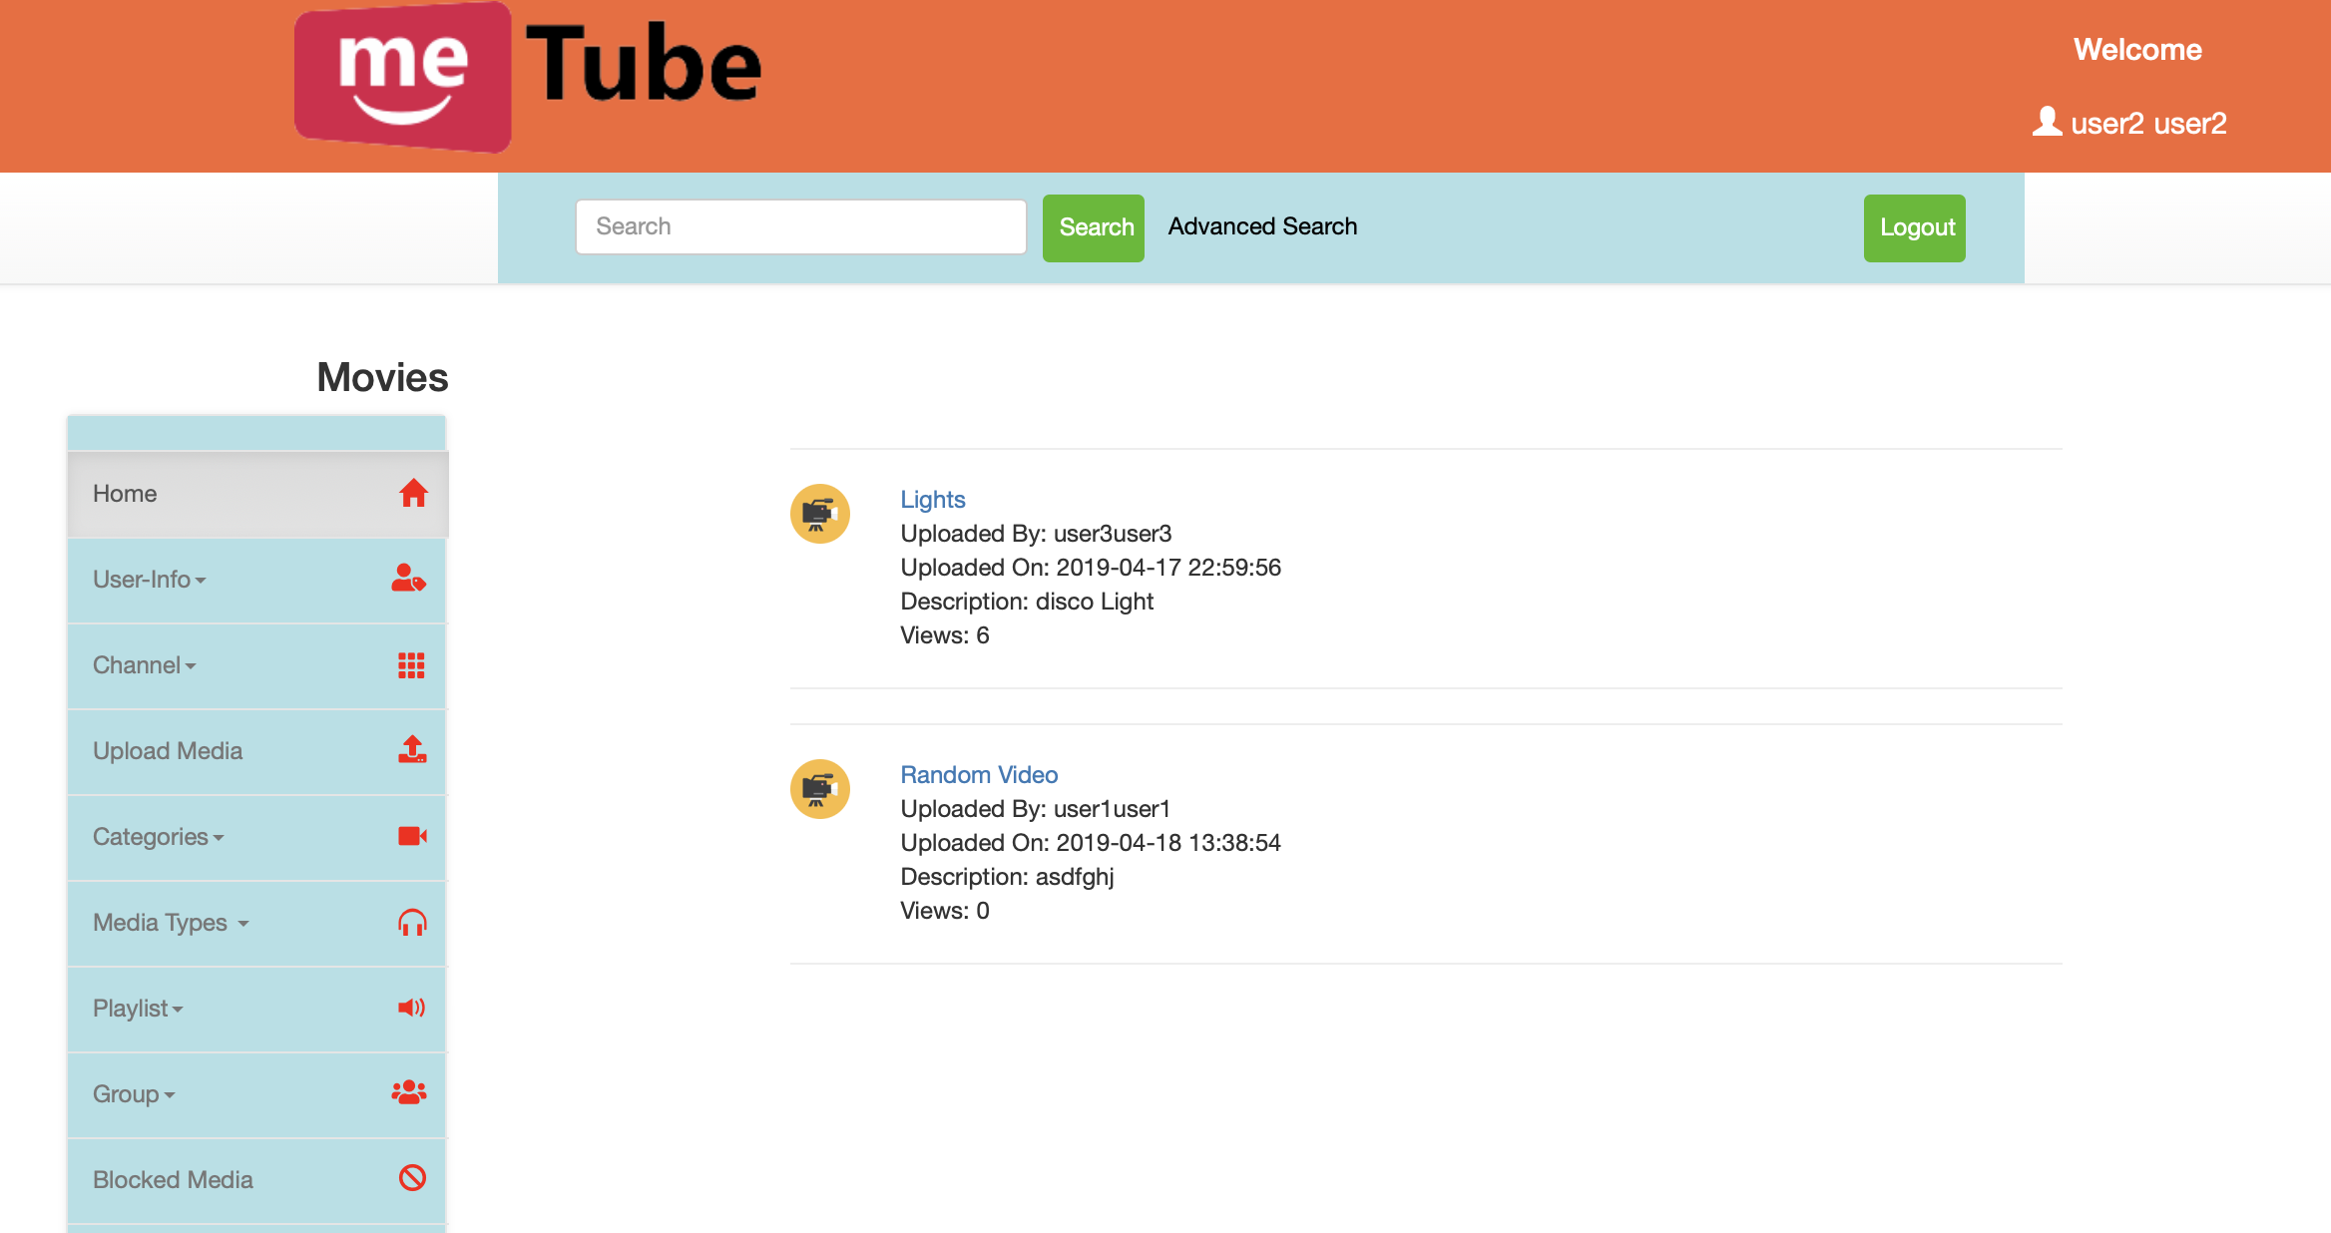

**Testing Result: Pass**

**Case 7:**

All the media files uploaded by the users are associated with their channels that other users can subscribe to. A user can subscribe to any channel which is created by another user and also cancel the subscription to the same at any point.

**Steps:**

1. Click on “Channel” in the sidebar on the left.
2. Click on “Explore Channel” and you will find the list of channels that are created by the user.
3. Checkbox the channels that you are interested in subscribing for and click on the “Subscribe Channel” button at the end.

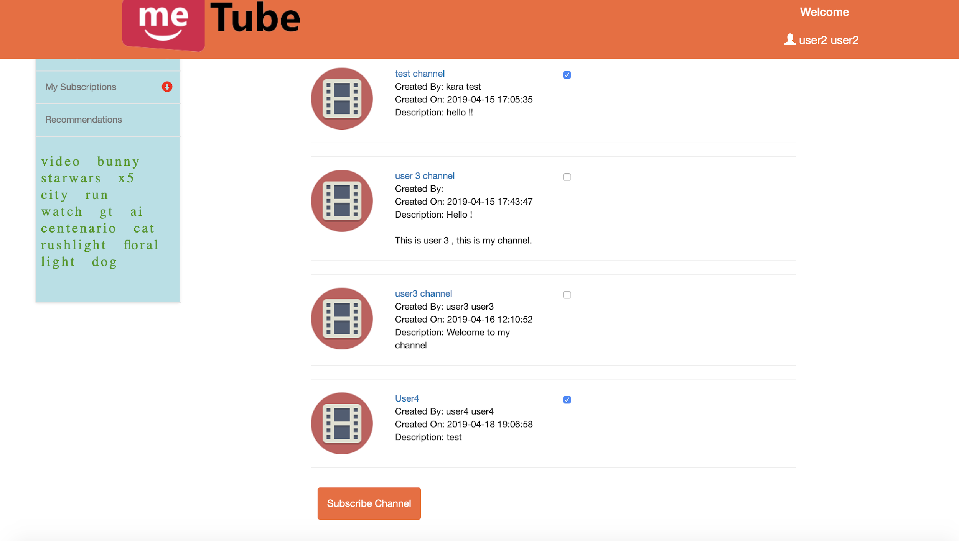

1. Click on “My Subscriptions” present in the bottom of the sidebar on the left in order to view the channels that you are subscribed to.

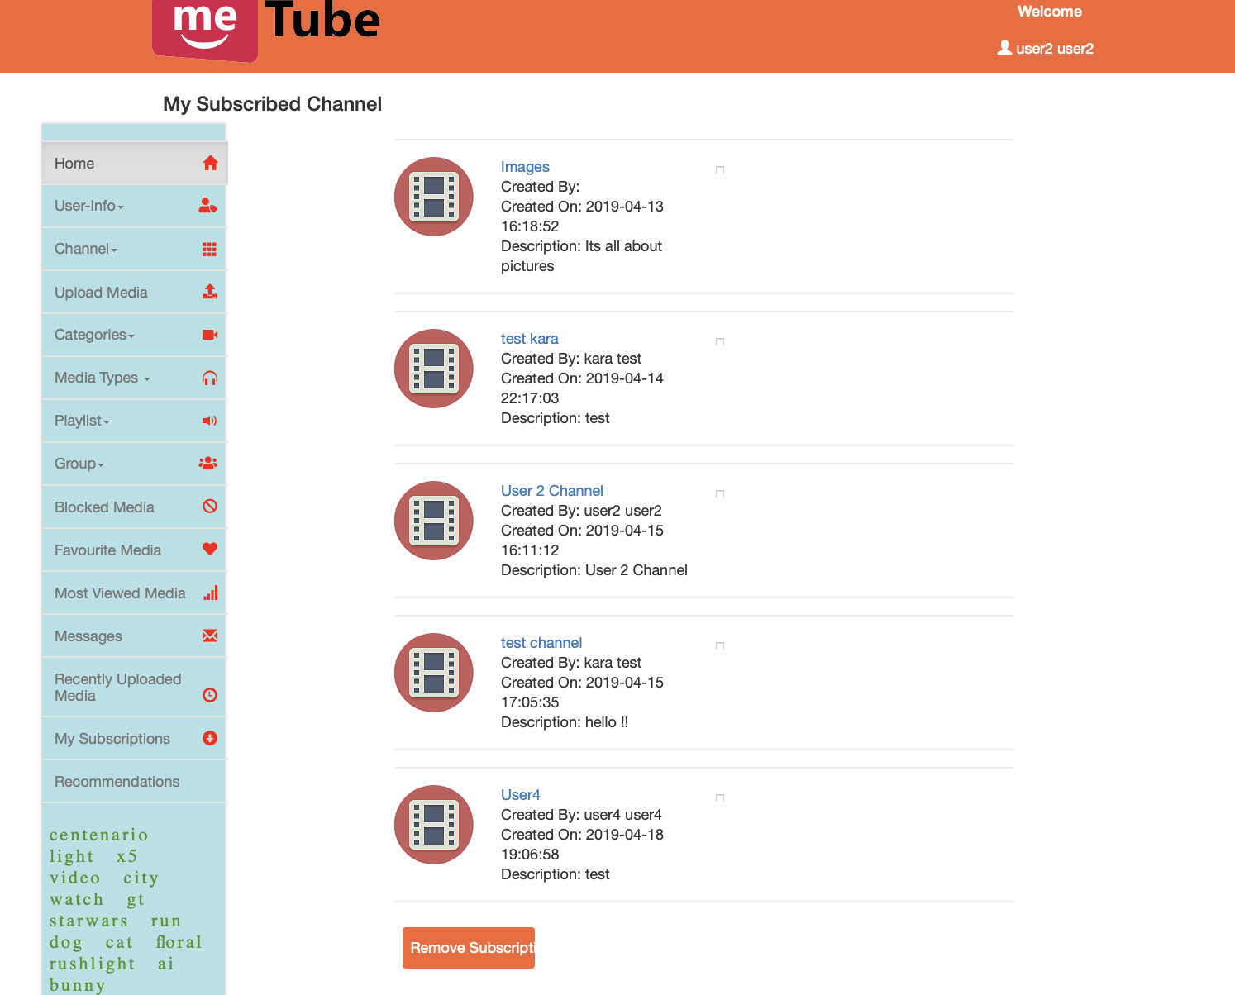

**Testing Result: Pass**

**Case 8:**

User can also associate the media files that are uploaded and viewed into their own playlist. A user can add and remove media files from the playlist and user can create any number of playlists required.

**Steps:**

1. Click on “Playlist” in the sidebar on the left.
2. Click on “Create Playlist” and create a playlist as per your wish.

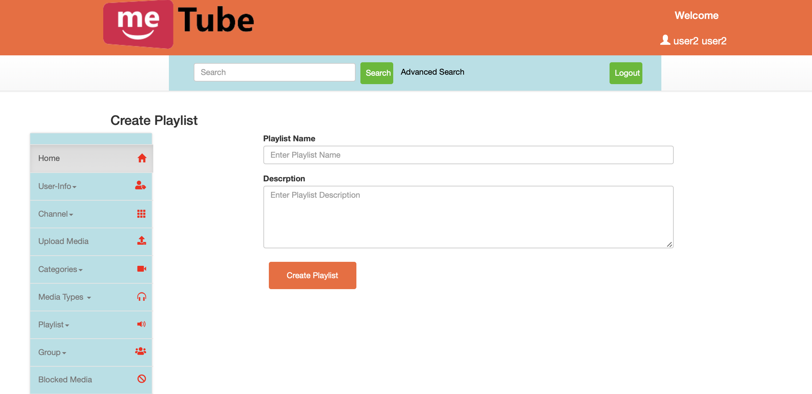

1. Then go on “Associate Media” and add the required media into the playlist created.
2. In order to confirm click on “My Playlist” and select the playlist created and see if the media files added to the playlist are present or not.
3. Go to “My Playlist” and click on the playlist you added the media to and checkbox the media files that you want to remove and click on “Remove Media” and confirm if it was deleted.



**Testing Result: Pass**

**Case 9:**

User can create a list of favourite media and can add or remove media files from his/her favourite media list as and when needed.

**Steps:**

1. Open any media file that you wish to add to your favourite list.
2. Click on the “Favourites” button which is available in the media options.

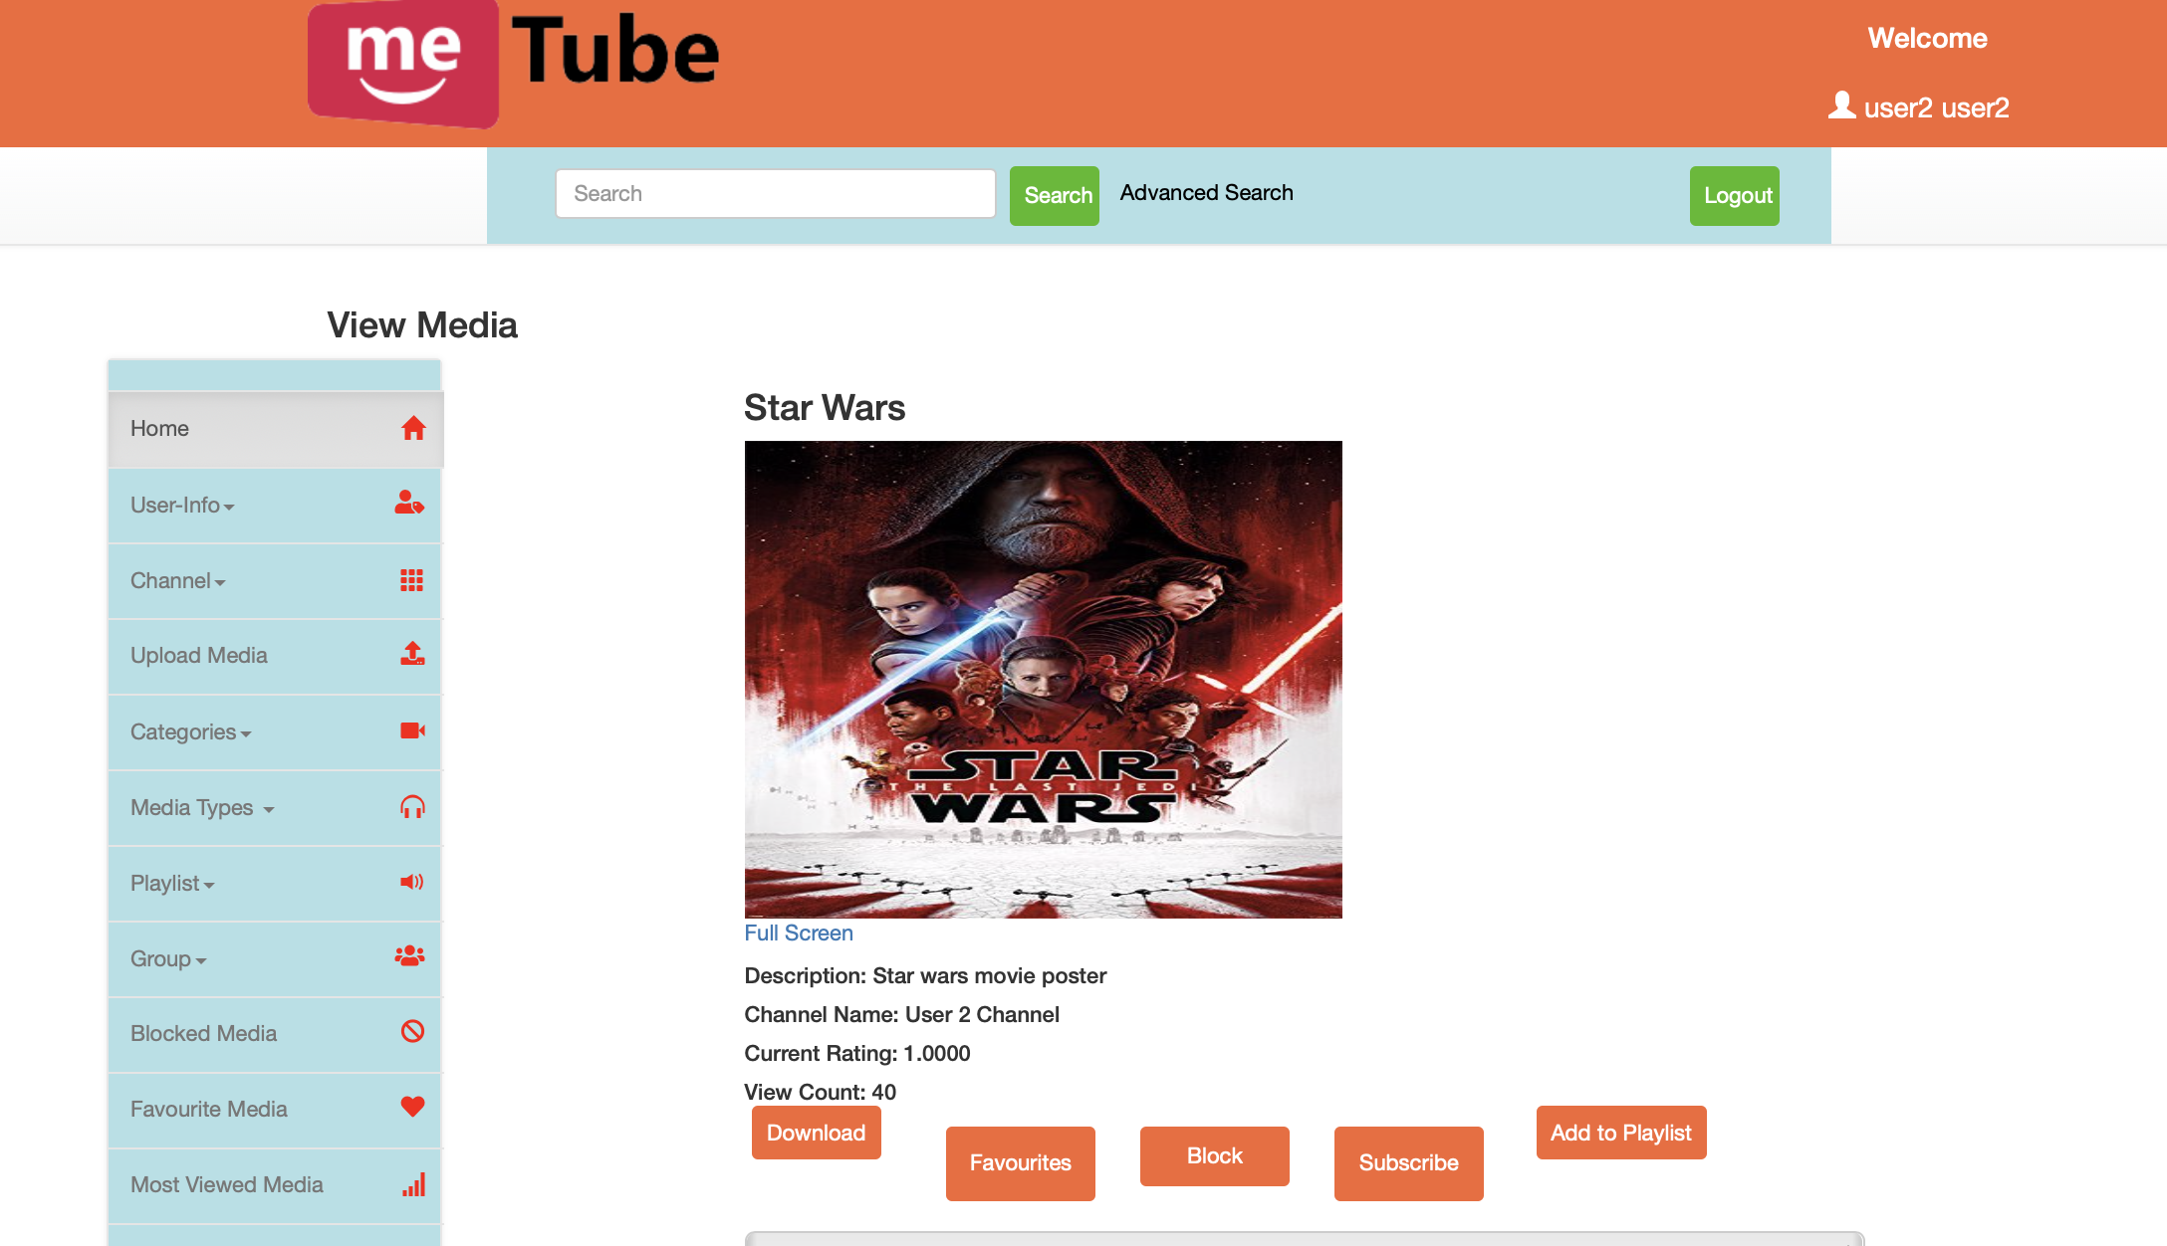

1. In order to confirm that the media is added to the favourite media. Click on “Favourite Media” and confirm the same.
2. In order to remove any media from the favourite list. Checkbox the ones you want to remove and click on “Remove Favourites”.

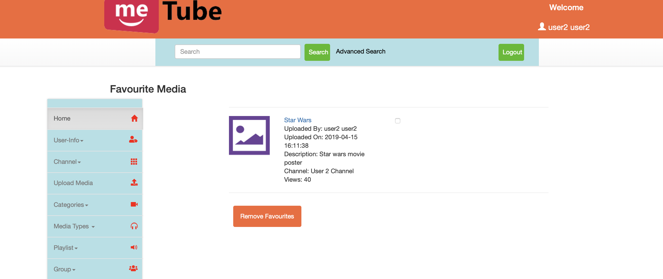

**Testing Result: Pass**

**Case 10:**

Users can also view the most recent media files based on the number of views by different users. Also the users can view the most recently uploaded media files based on the upload date.

**Steps:**

1. Click on “Most Viewed Media” in order to view the media files based on the order of their number of views by different users.
2. Confirm if the media files are ordered correctly.

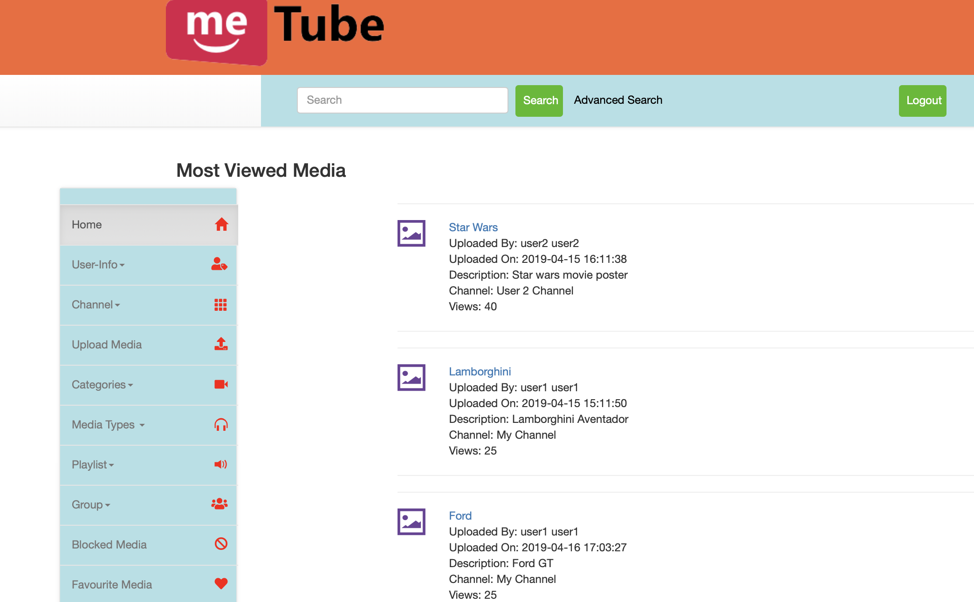

1. Click on “Recently Uploaded Media” to view the media files based on their upload date.
2. Confirm if the media files are ordered correctly.

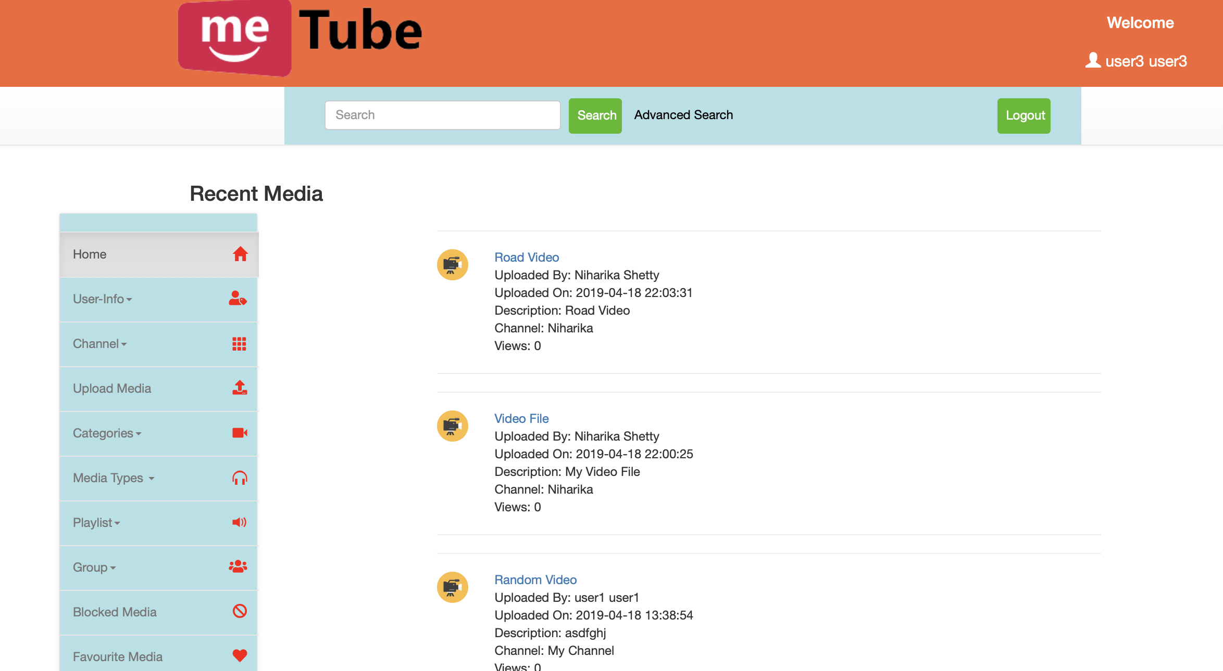

**Testing Result: Pass**

**User Manual/Instructions:**

Clemson metube is an online multimedia database which has the following features:

1. Register and create a new metube user account to access the website or login as guest to view the various features provided.
2. After successful registration, user can edit the account, delete the account, logout.
3. He can create contact list, add users as friends, or block users.
4. User can create new channel, subscribe to existing channel, delete channel.
5. Upload different media types such as images, videos, animated shows, music, racing sports, etc.
6. Define rights for each media type such as access rights , download rights, comments , rating etc.
7. User can block any other user from viewing the media from his channel
8. User can comment on other’s channel posts.
9. User can view word cloud.
10. User can perform advanced search.